Firebase for Mobile App Development

Having a stable, interactive, and scalable app is all that you need regardless of the company your business belongs to. Currently, many end users have adopted vast reliance on mobile applications. Therefore, the kind of mobile applications churned into the market should be efficient and meet the needs of individual users. To achieve all these, every development team or individual developers should focus on building powerful business applications that satisfy the needs of intended users. But achieving all these requires a strategical approach by incorporation of various external supportive ideas. But everything seems way more powerful when a powerful company such as Google delivers to the market a powerful platform such as Firebase.

Firebase is a product of Google which helps developers to build, manage, and grow their apps easily. It helps developers to build their apps faster and in a more secure way. No programming is required on the firebase side which makes it easy to use its features more efficiently. It provides services to android, ios, web, and unity. It provides cloud storage. It uses NoSQL for the database for the storage of data.

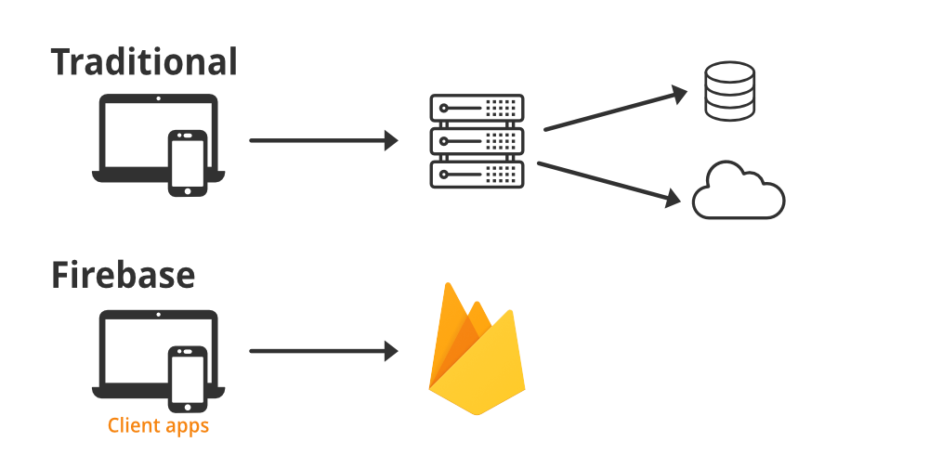

**Definition of Firebase**

When one speaks of Firebase, then immediately think of one of the best Backend-as-a-Service for web and mobile phones to develop the most powerful applications. Firebase has a range of solutions to offer when it comes to developing applications critical for guaranteed effective end usage. With Firebase, both Android and iOS mobile applications can run more efficiently and effectively.

**The purpose of Firebase**

A real-time database is all that Firebase is aimed at. Additionally, Firebase offers Backend-as-a-Service. It is a cloud-hosted database with no SQL. With Firebase, there is guaranteed synchronization between user data.

Backend-as-a-Service gives developers an API that enables data to coordinate through customers and keep them on the cloud messaging server of Firebase. Additionally, Firebase is also essential in synchronizing browsers and devices using a similar database. All these are done in real-time.

With Firebase, developers can focus on enhanced customer experience. With it, you need not control servers or write APIs. In short, Firebase is just but a server, an API, and a data store where modification as per individual needs can occur.

**Creating a Firebase account**

If you need to have a firebase account, visit https://console.firebase.google.com. On the website, you simply have to click on the plus icon and add your new project. After doing so, the firebase google console moves customers to the dashboard. The present features will appear on the left side of the dashboard. A further description is also provided for each related project. You can try out on a single demo account where users can add and even delete their products.

**Advantages of Firebase**

Several advantages make Firebase unique and outstanding. The following advantages make it a framework recommendable for [web and mobile applications](https://www.aalpha.net/articles/ux-design-principles-for-web-mobile-app-development/):

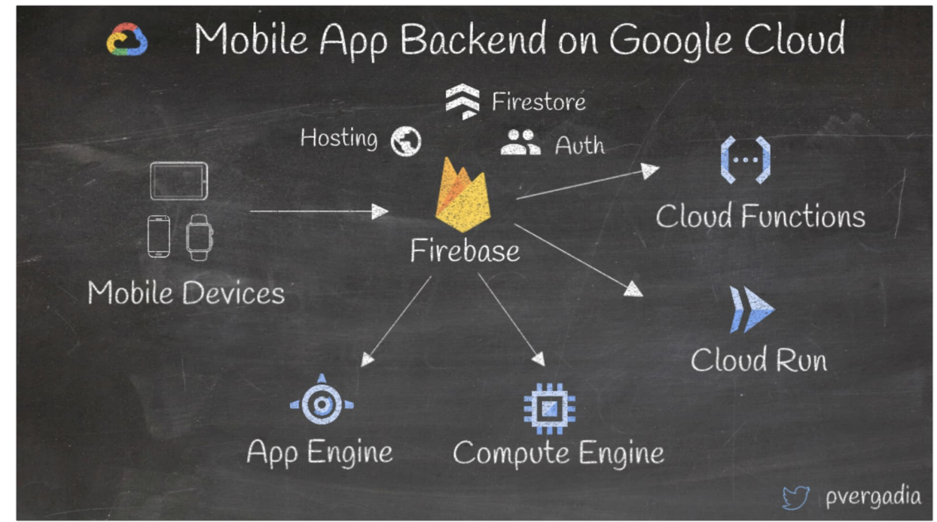

**Real-time Database**

Firebase is a NoSQL database. Data is kept and synced with the JSON design way. As a result, every user is connected in real-time. Furthermore, every user can gain access to data of their own from any given device. Any changes that occur in the customer’s application are automatically synchronized. Most importantly, all these can work in offline mode.

**Web Hosting**

Sometimes hosting a website can be tedious and tough. But in **Firebase app development**, everything is easier. Auto-provisioned SSL certificates, Global CDN, and custom domain support freedom are some of the new features essential here. Once your application is ready, you can quickly deploy it after Firebase CLI is fully set up. With Firebase, progressive web applications, [single-page applications](https://www.aalpha.net/blog/know-about-single-page-application/), among others, can be hosted without much effort. Hosting backed up with SSD helps transfer data fast.

**Firebase Authentication**

It’s boring to log into an application strenuously. But developers always strive much harder to ensure the login facility is easy, secure, and simplified. Firebase authentication is geared towards simplifying the sign-in process. Most applications will always request for users’ data, and therefore with Firebase, backend services are the easiest. Furthermore, there is an instant provision of libraries once validation services are requested. Identity is made easier through phone numbers, twitter, email and password, and much more. Therefore, the feature Firebase authentication is essential in the faster development of high-level security systems improved sign-in experiences for final users. A user interface, such as the Firebase one is the most essential as it is customizable and scalable. Additionally, high-security levels are guaranteed.

**Powerful Storage Space**

With Firebase, all your storage shortages are already handled. There is vast storage; hence development teams can properly handle content generated by end-users. With this feature, the end-users can share, transfer, and download files regardless of the internet speeds. Google cloud storage supports this feature. Most importantly, there is a proper cost-effective approach to managing content generated by users.

**Integrated Google Analytics**

With Firebase, you can easily access Google Analytics for your application. Further integration has made it easier for proper tracking of user history across devices. It’s free and supports a lot of various events defined using Firebase SDK. With this feature, you can also send data from a mobile application to BigQuery to understand general user behavior, interaction, and experience.

**Firebase Cloud Messaging (FCM)**

Firebase features Cloud Messaging as an essential feature as well. This feature provides a reliable connection between devices and the server. With this feature, you can send and receive messages as well as notifications on the web or Android. The maximum limit for sending notification messages is 2 kilobytes, and the maximum limit for data messages is 4 kilobytes.  With the **Firebase Cloud Messaging** service, you can consistently track messages with already defined segments and then learn from history before generating your messages.

Furthermore, this feature allows the sending of messages to a range of devices depicting a common historical behavior or even those that are subscribed to specific areas of interest. Additionally, message delivery is timely. But more surprisingly, no involvement of coding in this feature.

**Dynamic Links**

An active link is one that can be run in accordance to your requirements. Such links are best created by the **Firebase console**, which is loaded with a range of features. Users can click on such links on a website, and they will be directed to the desired content on your website or local application. If no such application is installed, then they can be redirected to a download destination such as Play Store. Once the [application](https://www.aalpha.net/services/application-development-india/) is installed, they can then navigate to their desired content.

**Remote Configuration Variables for Apps**

This feature allows the development team to change [mobile application](https://www.aalpha.net/services/mobile-app-development/) functionality with no need to launch another newer version. As a result, there is minimal time need when comparing to waiting for new data for personal applications.

Follow the steps below to know how to utilize Remote Configuration in your application.

* Include Firebase in your [mobile application](https://www.aalpha.net/articles/top-7-mobile-app-development-companies-in-2020-you-can-rely-on/)
* Acquire the Remote Configuration singleton object
* You then have to set default in-app default parameter values
* Seek for parameter values for use in the application
* Correctly set every parameter value in the Remote Configuration service
* Access and activate values from the service

**In-app Advertising**

You can raise your revenue a great deal through in-app advertisements. But Firebase enhances all these since boasts powerful in-app advertising features. The framework of this software is equipment with AdMob, which gives you the chance to permit the display of advertisements. As a result, there is an inflow of more income through ad revenues. But more importantly, a variety of templates are in for accommodating advertisements in your application.  Therefore, you can monetize your application via Firebase.

It is also essential to note that with Google Analytics, we can encourage installs, seek target ad viewers, and deeply explore ad conversions to suit the Firebase audience. An added advantage comes in when linking Firebase with AdWords. With such links, you will have the privilege of managing tools. You will, therefore, understand the need for app installs and activities within your application.

**Conclusion**

Firebase is one of the major options. It’s a unique and impressive platform for the development of mobile applications. It’s a Google-based platform with the assurance of scalable, robust, and dynamic framework features. It now emerges as a powerful platform that poses a threat to companies providing web services. While this piece shares much about Firebase, there is even much more to explore. If you need to substantiate and enhance your business-based application, then a trial of the **Firebase platform** can be quite promising.

